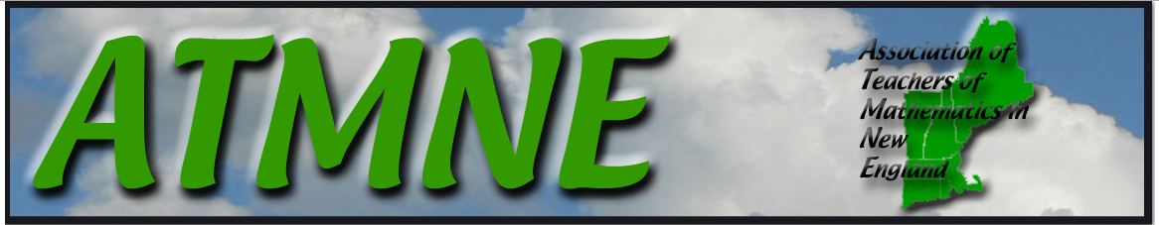
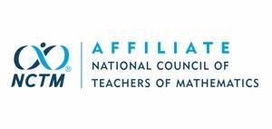
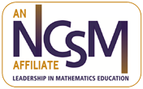
This Month in ATMNE
March 2022
Opportunities from New England Affiliates

From ATOMIC
- Please visit ATOMIC’s website at atomicmath.org for updates and opportunities.

From ATMIM
- Please visit ATMIM’s website at https://atmim.wildapricot.org/ for updates and opportunities.

From ATOMIM
- ATOMIM looks forward to welcoming Pam Harris as their keynote speaker at their Virtual Spring Conference on Saturday, March 22, 2022. There is a great lineup of speakers (the complete list can be found at https://bit.ly/3vIAPbU). Registration is open until Thursday, March 24, 2022 at atomim@wildapricot.org.

From NHTM
- The New Hampshire Teachers of Mathematics (NHTM) is hosting its 2022 Spring Conference "A Night of Notice and Wonder" virtually on March 23. Annie Fetter will deliver the interactive keynote presentation, "Notice and Wonder: Gateway to Student Sense-Making."

Annie consults with schools, districts, states, and speaks at conferences, encouraging a focus on sense-making and leveraging students’ ideas. Annie is a contributing author of McGraw Hill Education’s new K-5 textbook series, Reveal Math, and works part-time for the 21st Century Partnership for STEM Education, continuing the Math Forum’s research and outreach. Annie’s very first Ignite talk, “Ever Wonder What They’d Notice?", has been used in countless PD sessions around the world.

The Spring Conference will be an online event offered through Zoom, starting at 4:30 pm. The conference will be open to the first 300 participants that sign up for the virtual Zoom meeting.

- The NHTM website is www.nhmathteachers.org. Go there to register for the above events and to renew your membership for the 2022-2023 school year.

From RIMTA
- RIMTA’s Virtual Spring Conference is scheduled for March 24-26, 2022, with keynote speakers Michael Steele (co-author of Taking Action: Implementing Effective Mathematics Teaching Practices and The Five Practices in Practice) and Zandra de Araujo (co-author of Putting Essential Understanding of Expressions and Equations into Practice, Grades 6-8). The conference will also feature a “Merry Math Hour” (an online networking/social event with trivia and prizes), awards presentations, and a raffle. Register today at www.rimta.net.

From VCTM
- Please visit VCTM’s website at vctm.wildapricot.org for updates and opportunities.

From ATMNE
- The calendar for upcoming ATMNE Twitter chats is as follows;
- March 7, hosted by RIMTA with guest Zandra de Araujo
- March 21, hosted by ATMIM with guest Deborah Peart

Chats begin at 7:00 pm ET. To access the chats live or to view conversations from past chats, use the hashtag #ATMNEchat. See you there!

- Please visit ATMNE’s website at https://sites.google.com/view/atmnemath/home for updates and opportunities.

