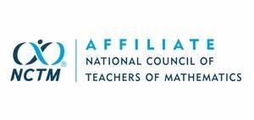
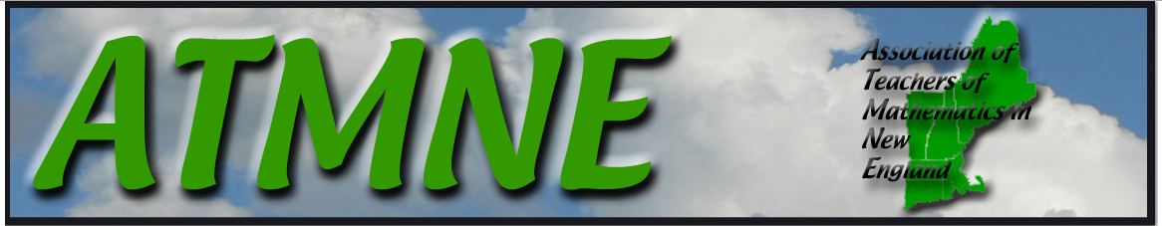
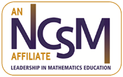
This Month in ATMNE
March 2021
Opportunities from New England Affiliates

From RIMTA
- RIMTA will host its Spring Conference from March 10-13. The conference will be virtual and FREE for all. The conference will feature keynote presentations from Robert Berry, Mike Flynn, and Erica Jordan-Thomas; nearly 20 additional sessions to enhance your professional practice, raffle prizes, and a social hour/trivia night. Registration is open at www.rimta.net/events.

From ATMIM
- Educator Meet Ups have been a great resource for mathematics educators across Massachusetts to collaborate during these unprecedented times. Please consider joining our next Educator Meet Up where we will collaborate, reflect and share strategies about the past year. You do not need to be a member of ATMIM to attend. ATMIM is looking forward to continuing this collaboration throughout the school year.
Next Meet Up: Wednesday, March 24th from 8 - 9 pm Topic: It's Been a Year: get some fresh perspective and celebrate our successes! Register Here!
- ATMIM is excited to offer a series of four monthly webinars that are FREE for all members. Not a member? A regular one year membership is only $20 (reduced rates for first year teachers, retired teachers, and students). The next webinar is on March 9th, 7:00-8:00 PM, on Engaging Students in Problem-Based Learning in Remote and Hybrid Settings with Dr. Mike Flynn. Register Here . The April webinar is on April 13th, 7:00-8:00 PM, on Mastering the Art of Questioning to Differentiate and Engage Students in Any Learning Environment with Dr. Alison Mello. Register Here

From ATOMIC.
- ATOMIC is offering a book study for “Becoming the Math Teacher You Wish You’d Had”. Anyone can join for free and you can jump in at any time. Contact atomicbookclub@gmail.com for more information.
- The 2021 ATMNE Conference will be hosted by ATOMIC at the Crowne Plaza in Danbury, CT on Dec 3-4, 2021. They will still be evaluating the proposals already submitted for the postponed 2020 ATMNE Conference, but an additional Call for Proposals for this same event that will be evaluated alongside the previous submissions. Please share a lesson or teaching strategy in a 60 minute presentation or 75 minute workshop. Presentations will be in theater style seating. Workshops will be set up with round tables for participants to take a more active role in the learning. The deadline for submission is May 28, 2021. Early submission is encouraged. Go to www.atomicmath.org for more information or to submit a proposal.

From ATOMIM
- The Association of Teachers of Mathematics in Maine (ATOMIM) Board Conference Committee Members are getting ready for their Spring Conference! It will be virtual on March 13, with Keynote Speaker Peg Smith. Featured Speakers include Maggie McGatha, Donna Karsten, and Sara Frisbee. All are invited to join for a great day of professional learning with many offerings for all grade spans! Continue to check the ATOMIM website and social media for updates on the program! The cost will be $25 for a day of professional learning. Registration at this link.

From NHTM
- The NHTM 2021 Conference and Business Meeting will be a free Virtual Meeting on Thursday, March 18 from 4:30 – 7:30, with a Dine and Discuss format. Bring your own dinner and spend the evening networking with New Hampshire mathematics teachers. NCTM President Trena Wilkerson will deliver the keynote address, “Teaching and Learning Mathematics: Transforming Challenges into Opportunities to Move Forward”. Donations to NHTM of any amount are greatly appreciated. Register at www.nhmathteachers.org .

From ATMNE
- ATMNE has two Twitter chats scheduled for this month, the first on March 7 (hosted by VCTM) and the other on March 21 (hosted by ATOMIC). All chats are held on Sunday evenings starting at 7:00 p.m., using the hashtag #ATMNEchat.

From Other Organizations
- The World Science Scholars program is looking for the next group of exceptionally talented mathematical minds from around the world. Do you know students ages 14-16 who could be one of this select group of scholars?
World Science Scholars, an initiative of the World Science Festival, is a two-year program that fosters and sustains a vibrant community of outstanding math students, esteemed professors, and dedicated teaching fellows. Together, they grapple with challenging ideas and explore new disciplines in which to apply their abilities. Scholars have the unparalleled opportunity to interact directly with leading experts and join a long-lasting community of peers and mentors.

Help find the next World Science Scholar who will learn from top scientists and become leaders who change the world. NOMINATE NOW at http://bit.ly/WorldSciScholar21. #MathTeacher #STEM#WorldSciScholar @WorldSciFest

